Enterprise Router

🏢 What is an Enterprise Router?
# Source: AI Source: Provided by: [Data Path: Persons Table -> ID Column: 1, Name_En Column: Motasem Essam] -> From: [ChatGPT] on [12/18/2025]
An Enterprise Router is a high-performance network router used in large businesses, organizations, or data centers. Unlike home routers, enterprise routers are designed to handle heavy traffic, multiple networks, advanced security, and custom configurations across large-scale or mission-critical environments.

🔧 Key Features of Enterprise Routers
# Source: AI Source: Provided by: [Data Path: Persons Table -> ID Column: 1, Name_En Column: Motasem Essam] -> From: [ChatGPT] on [12/18/2025]
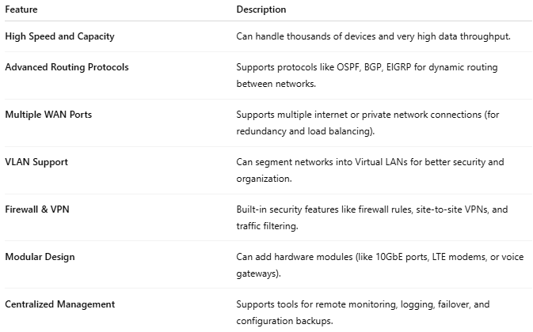
Feature | Description
High Speed and Capacity | Can handle thousands of devices and very high data throughput.
Advanced Routing Protocols | Supports protocols like OSPF, BGP, EIGRP for dynamic routing between networks.
Multiple WAN Ports | Supports multiple internet or private network connections (for redundancy and load balancing).
VLAN Support | Can segment networks into Virtual LANs for better security and organization.
Firewall & VPN | Built-in security features like firewall rules, site-to-site VPNs, and traffic filtering.
Modular Design | Can add hardware modules (like 10GbE ports, LTE modems, or voice gateways).
Centralized Management | Supports tools for remote monitoring, logging, failover, and configuration backups.

🛠️ Use Cases for Enterprise Routers
# Source: AI Source: Provided by: [Data Path: Persons Table -> ID Column: 1, Name_En Column: Motasem Essam] -> From: [ChatGPT] on [12/18/2025]
- Corporate headquarters with multiple floors or departments.
- Data centers handling traffic from multiple clients or cloud apps.
- Retail chains connecting multiple branches securely.
- ISPs or telecom providers that route traffic for customers.

🖥️ Example Brands / Models
# Source: AI Source: Provided by: [Data Path: Persons Table -> ID Column: 1, Name_En Column: Motasem Essam] -> From: [ChatGPT] on [12/18/2025]

Brand | Example Enterprise Router
Cisco | Cisco ISR 4000, ASR Series
Juniper | MX Series, SRX Series
Fortinet | FortiGate Routers (with firewall)
Ubiquiti | EdgeRouter Infinity
MikroTik | CCR (Cloud Core Routers) Series

🆚 Comparison: Home Router vs Enterprise Router
# Source: AI Source: Provided by: [Data Path: Persons Table -> ID Column: 1, Name_En Column: Motasem Essam] -> From: [ChatGPT] on [12/18/2025]
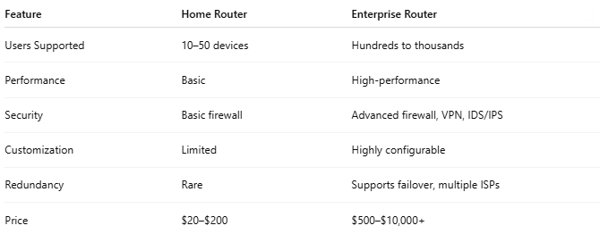
Feature | Home Router | Enterprise Router
Users Supported | 10–50 devices | Hundreds to thousands
Performance | Basic | High-performance
Security | Basic firewall | Advanced firewall, VPN, IDS/IPS
Customization | Limited | Highly configurable
Redundancy | Rare | Supports failover, multiple ISPs
Price | $20–$200 | $500–$10,000+

